**Intro**

Java is an object oriented programming language. Developed by James Gosling at Sun Micro Systems in 1995.

* Simple
* Portable
* Architecture Neutral
* Platform Independent

JVM (Java Virtual Machine) - translates a particular code into the native code.

**Process**

Environment

1. Development Environment
   1. Tools for Development (Eclipse/NetBeans)
   2. Syntax & Semantics - JDK (Java Development Kit)
      1. Javac program_name.java
      2. Compilation
      3. Program_name.class - ByteCode/Class Files
      4. ByteCode runs on JVM (Java Virtual Machine)
2. Execution Environment
   1. JRE (Java Runtime Environment) - takes bytecode to translate into understandable machine code.

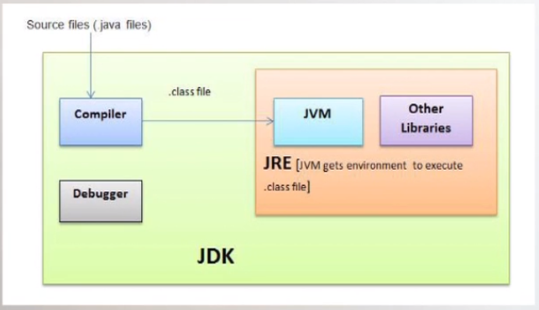

**Data Types**

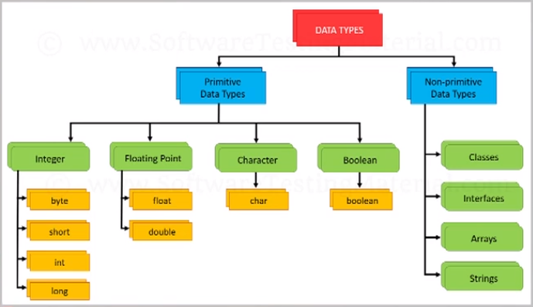

**Features of Java**

* OOP language
* Platform Independence
* Architecture Neutral
* Secure
* Robust
* Memory Management
* Multi thread

